# Media Analysis - Is the Arab world ready for the uncertain age of AI-powered web tools_Updated 09 March 2023

## Short Summary

The article discusses the impact of artificial intelligence AI on various aspects of society, including education, employment, and media.

## Summary

The article discusses the impact of ChatGPT, a large-language model (LLM) chatbot, on various industries such as education, media, and job market. Here are some key points from the article:  
  
**Education:**  
  
* Some colleges have reintroduced paper-based tests to prevent students from using AI during exams.  
* New York City's education department has banned ChatGPT on its networks due to concerns about negative impacts on student learning.  
* A group of Australian universities have also said they would change exam formats to prevent AI cheating.  
  
**Job Market:**  
  
* The article highlights the potential impact of ChatGPT on jobs, particularly in fields such as writing and content creation.  
* However, experts argue that AI is not going to completely replace human professionals, but rather augment their abilities.  
  
**Media and Journalism:**  
  
* Jenna Burrell, director of research at Data Society, warns that people need to take ChatGPT's answers with a pinch of salt, as the information it provides may not be up-to-date or accurate.  
* Experts also note that AI is not capable of replacing every professional function, as it cannot fully imitate human innovation, creativity, skepticism, and reasoning.  
  
**Investment Potential:**  
  
* The article mentions that forecasts value the AI industry in trillions of dollars, making it a significant investment opportunity.  
* However, experts emphasize the need for caution and responsible use of AI solutions to ensure their safe expansion around the world.  
  
**Reassurances from Experts:**  
  
* Ahmed Belhoul Al-Falasi, UAE minister of education, insists that ChatGPT should not be demonized, as it will become a part of our lives.  
* Dr. Scott Nowson, PwC Middle East's artificial intelligence lead, emphasizes the need for trust and human intelligence in the use of AI solutions.  
  
Overall, the article highlights the potential benefits and risks associated with the rise of ChatGPT and other AI technologies, emphasizing the need for responsible innovation and use of these solutions.

## Question 1

The article frames the public discussion about ChatGPT in several ways 1. **Fear of replacement** The media highlights concerns that ChatGPT might replace human writers, journalists, and professionals, leading to job losses and anxiety. 2. **Potential benefits** The article also mentions the potential benefits of ChatGPT, such as assisting in content creation, writing business plans, and providing medical reports. 3. **Concerns about cheating and misuse** The media discusses how ChatGPT can be used for cheating on exams, replacing search engines, or producing biased news coverage. 4. **Need for caution and fact-checking** Experts like Jenna Burrell and Dr. Scott Nowson emphasize the importance of verifying information generated by ChatGPT and not relying solely on its answers. Metaphors that keep cropping up in the article include 1. ** AI as a tool vs. AI as a replacement ** The media uses metaphors to describe ChatGPT as a tool that can assist humans, but also as a potential replacement for human professionals. 2. ** ChatGPT as a student ** The example of ChatGPT passing exams at Minnesota University Law School is used to illustrate its capabilities and limitations. 3. ** AI as a machine ** The article describes ChatGPT s language model as a machine for matching patterns, highlighting the differences between human understanding and AI processing. These metaphors reflect the complexities and nuances of the public discussion about ChatGPT, showcasing both the potential benefits and risks associated with this technology.

## Question 2

Based on the article, here are some perspectives and aspects that are being widely covered 1. **The potential benefits of AI** The article highlights various applications of ChatGPT, including content creation, medical diagnosis, and customer service. 2. **Concerns about cheating and academic integrity** Many universities and institutions have banned or restricted the use of ChatGPT during exams to prevent students from using it to cheat. 3. **The limitations of AI** Experts like Jenna Burrell and Scott Nowson emphasize that AI is not a replacement for human innovation, creativity, skepticism, and reasoning. 4. **The need for fact-checking and trust in AI solutions** The article highlights the importance of verifying information provided by AI systems like ChatGPT. Aspects that are being ignored or underrepresented 1. **Long-term implications of widespread AI adoption** While some experts express optimism about AI s potential, others emphasize the need to consider its long-term consequences. 2. **Social and economic inequalities exacerbated by AI** The article does not explore how AI might exacerbate existing social and economic disparities. 3. **Human-AI collaboration and hybrid intelligence** While the article highlights the limitations of AI, it does not delve into the potential benefits of human-AI collaboration or hybrid intelligence models. 4. **Regulatory frameworks for AI development and use** The article does not discuss the need for regulatory guidelines to govern AI development and deployment. Overall, the article provides a balanced view of the opportunities and challenges presented by AI, but there are some aspects that could be explored further.

## Question 3

The Arab world is mentioned as a region that will benefit from AI technology, with the Middle East projected to accrue 2 of the global benefits of AI by the end of the decade, equivalent to 320 billion. However, specific countries in the Arab world are not named or profiled in this article. But one minister from the United Arab Emirates UAE is quoted UAE Minister of Education Ahmed Belhoul Al-Falasi.

## Question 4

The final message of the article is that while AI has immense potential and benefits, trust and awareness are crucial to its safe expansion, and it s unlikely to completely replace humans in the near future.

## Sentiment

The sentiment is 1.0

## Entities

National Strategy for Data, Scott Nowson, Googles, the Sciences Po school, Nowson, Bard, DeenSquare, Generative Pre-Trained Transformer, AFP Founded, Edge, Microsoft, UAE, AI, PwC Middle Easts, Google, Minnesota University Law School, Peter Thiel, GPT, Ahmed Belhoul Al-Falasi, LinkedIn, Alexa, Guardian, Sam Altman, Burrell, LEAP, Reid Ho, Intelligence, James Webb, Bing, New York Citys, Alex Hern, Noaman Sayed, ChatGPT, Jenna Burrell, OpenAI, Data Society, the World Economic Forum, YouTube, AFP However, Dubais Museum of the Future, Elon Musk, Dan Milmo, Omar Sultan Al-Olama, Arab News

## Highlights

#7cc867: 48

#fb5b89: 43

#c885da: 19

#f9cd59: 55

## Wordcloud for #7cc867 Highlights

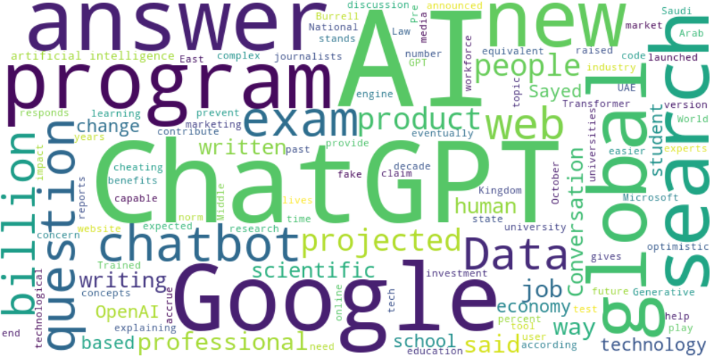

Top 10 words:

- AI: 16

- ChatGPT: 11

- Google: 7

- global: 5

- search: 5

- questions: 4

- web: 4

- billion: 4

- people: 4

- said: 4

## Wordcloud for #fb5b89 Highlights

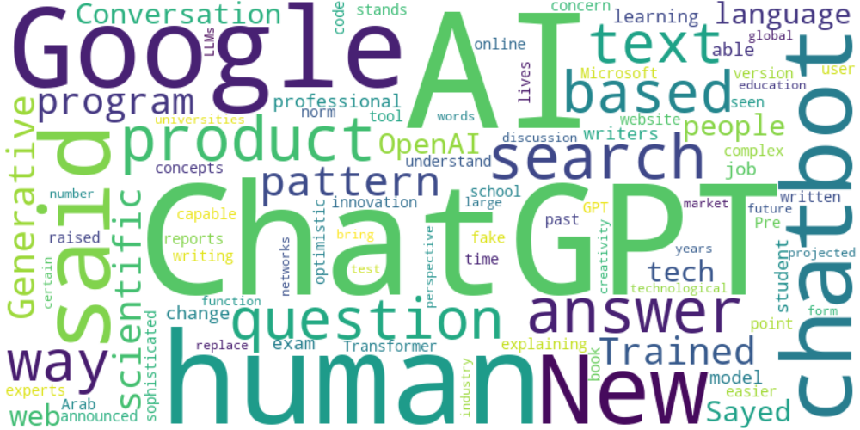

Top 10 words:

- AI: 12

- ChatGPT: 11

- Google: 7

- human: 5

- said: 5

- search: 4

- based: 4

- text: 4

- scientific: 3

- language: 3

## Wordcloud for #c885da Highlights

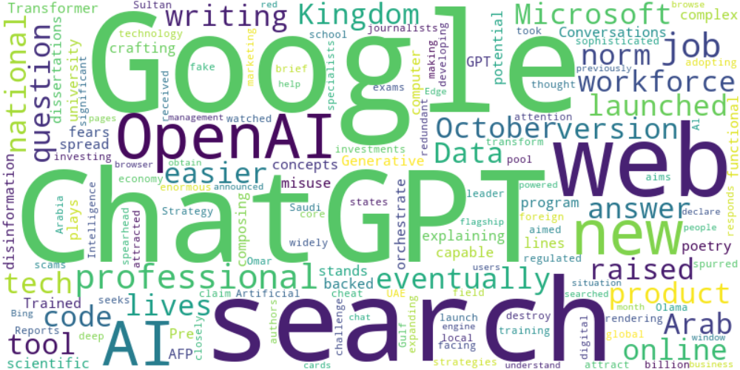

Top 10 words:

- Google: 6

- ChatGPT: 5

- search: 4

- web: 3

- OpenAI: 3

- AI: 3

- writing: 2

- code: 2

- Microsoft: 2

- raised: 2

## Wordcloud for #f9cd59 Highlights

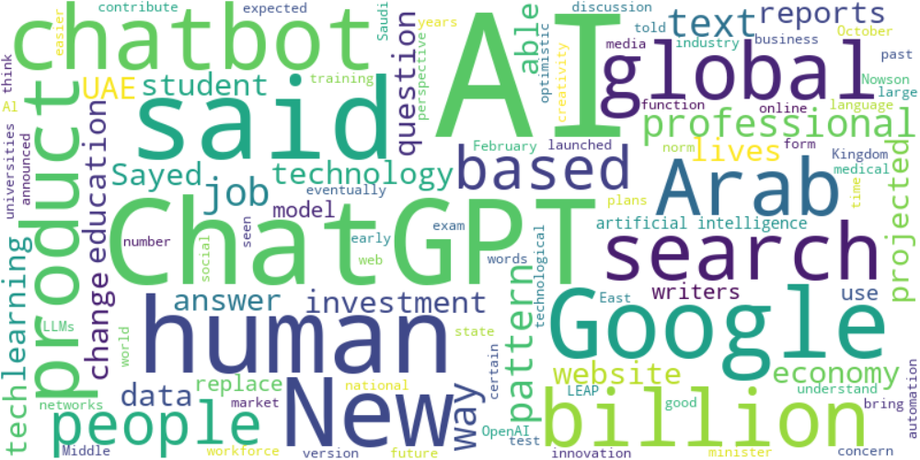

Top 10 words:

- AI: 24

- ChatGPT: 9

- said: 8

- Google: 6

- human: 5

- Arab: 4

- global: 4

- search: 4

- based: 4

- text: 4